# Kubernetes Dashboard

1.下載kubernetes-dashboard.yaml

#wget <https://raw.githubusercontent.com/kubernetes/dashboard/v1.10.1/src/deploy/recommended/kubernetes-dashboard.yaml>

2.修改port

# nano kubernetes-dashboard.yaml

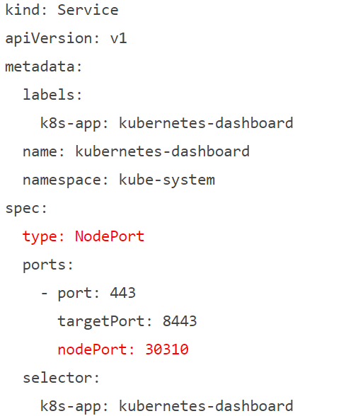

3.部屬 kubernetes-dashboard.yaml和 admin-role.yaml

# kubectl apply -f kubernetes-dashboard.yaml

# kubectl apply -f admin-role.yaml

4.取得token

# kubectl -n kube-system describe secret $(kubectl -n kube-system get secret | grep admin | awk '{print $1}') | grep token: | awk -F : '{print $2}' | xargs echo

5.login

# https://192.168.56.105(自己主機的ip)/#!/login

6.把token複製貼上去

7.成果

